**Step1 :Then type wsl –install to install the Ubuntu Distribution of Linux** **wsl –install This will install both WSL and Ubuntu**

* Give in a UNIX username and password
* UNIX username: mpstme_student
* Password: password

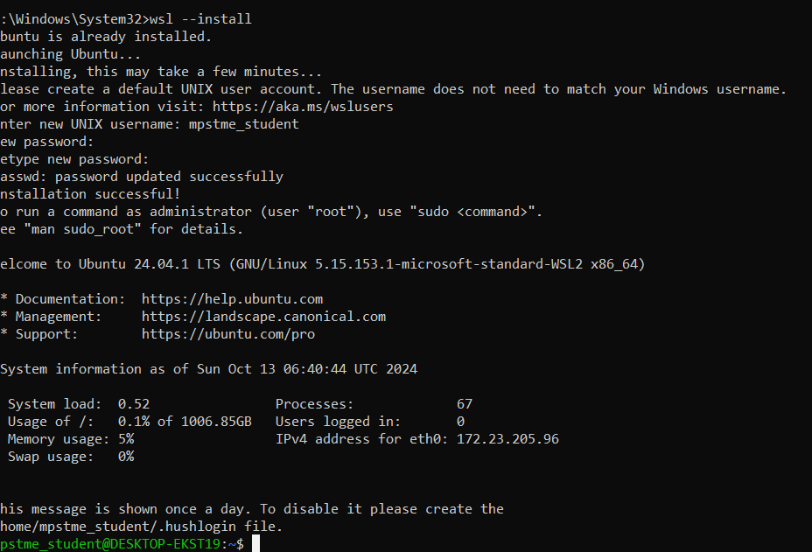

**Step 2: Run sudo apt update- to install all updates**

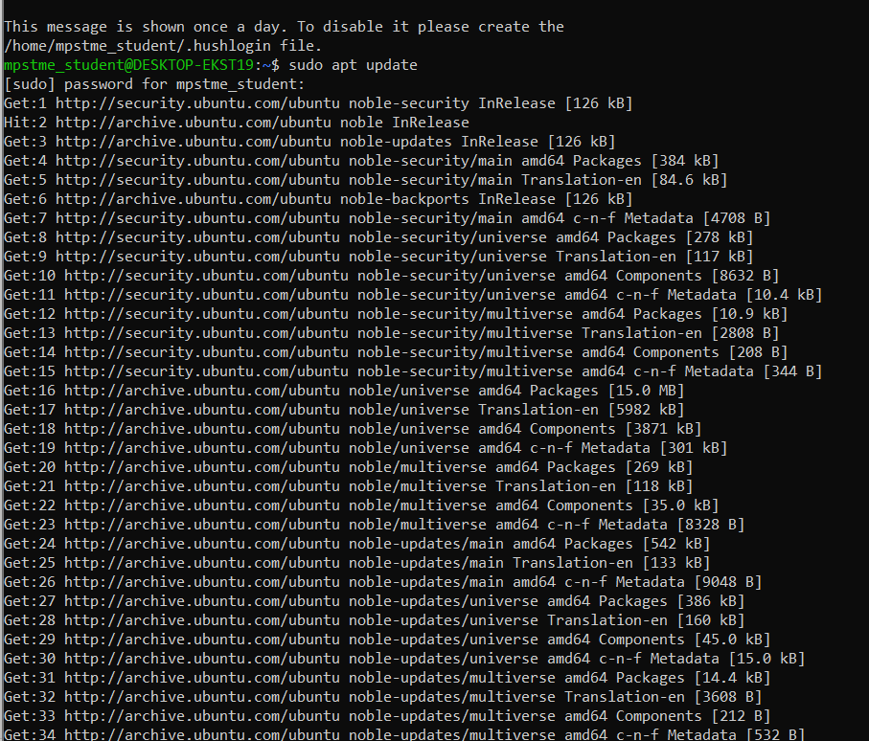

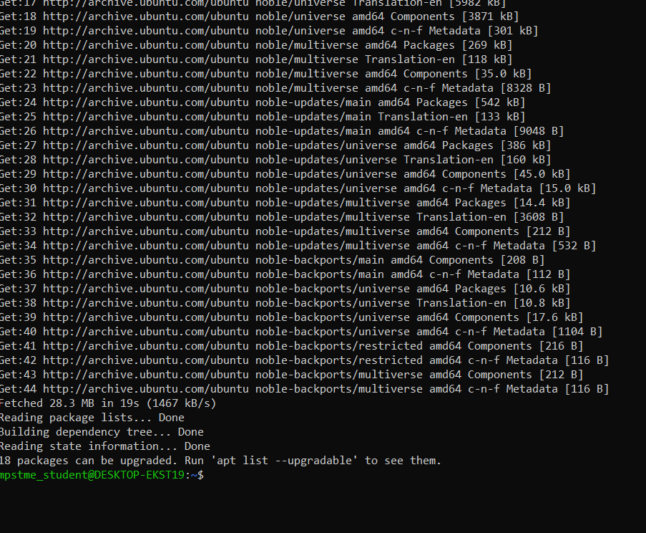

**Step3:** **Run the sudo apt-get install software-properties-common, to get all common properties**

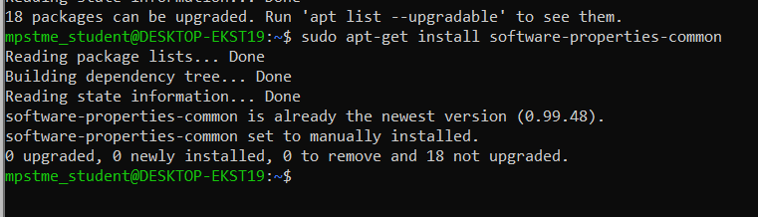

**Step 4: Run sudo apt-add-repository ppa:ansible/ansible to install repository**

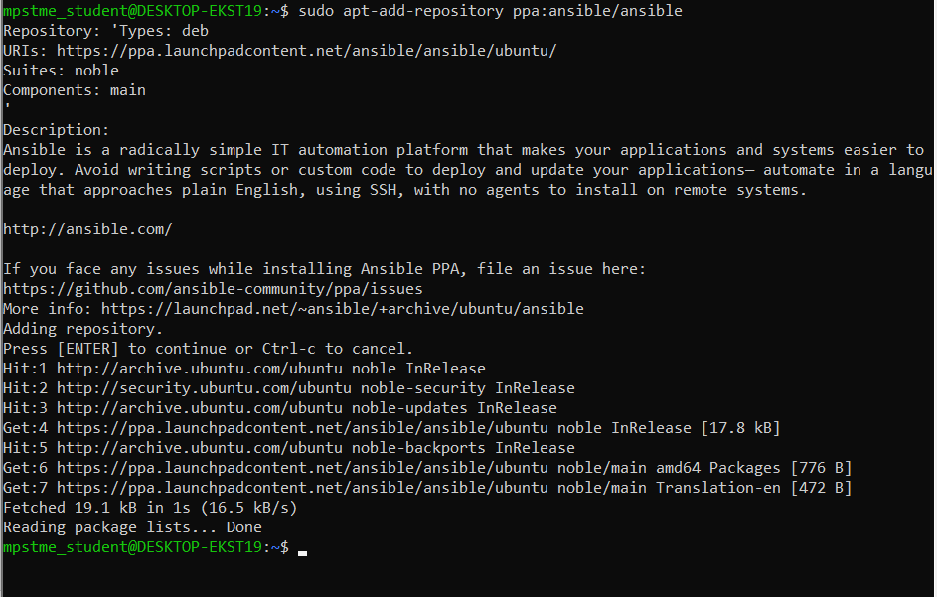

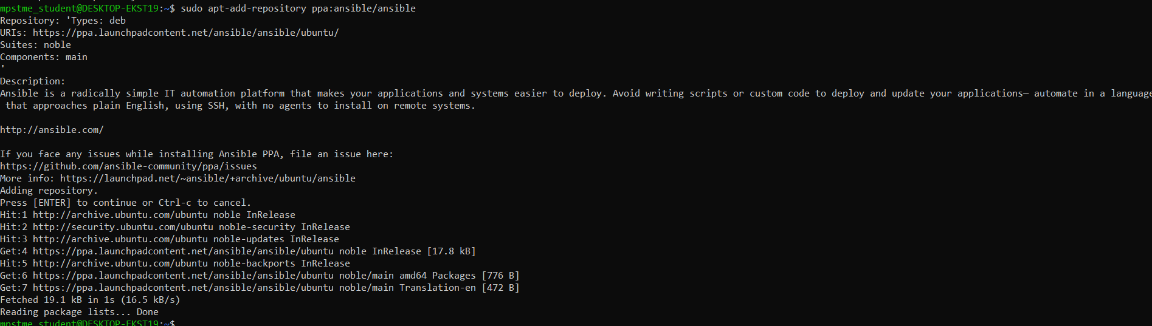

**Step 5: Run sudo apt update again to update the repository**

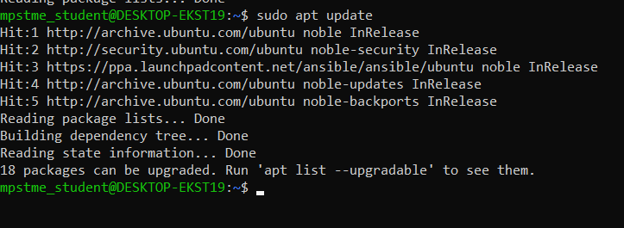

**Step 6: Run sudo apt-get install ansible**

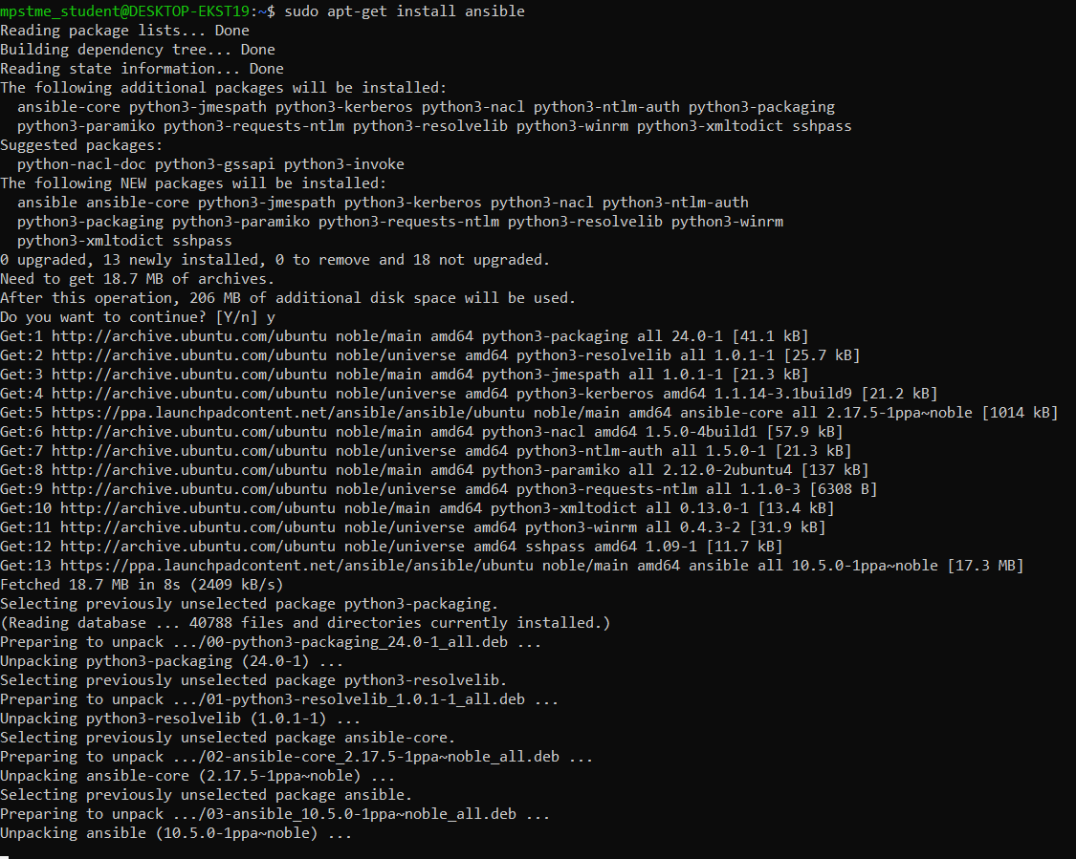

**Step 7: Run ansible --version**

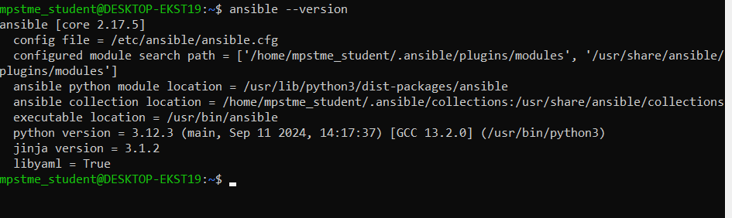

**Creating Remote Servers Using Docker and installing SSH**

**Install docker, from docker hub pull the image**

**Step 1: Pull Docker image of ubuntu from docker hub and run**

**docker pull ubuntu –on cmd**

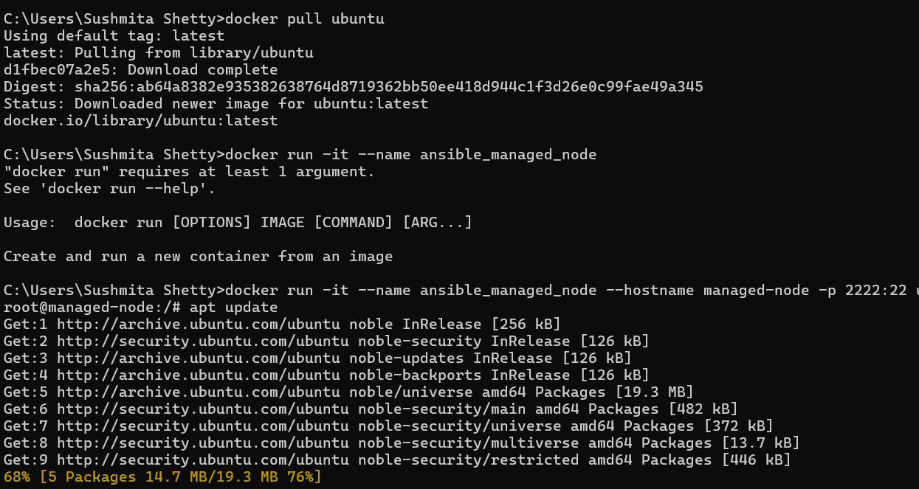

1. **In Docker Desktop, you should be able to see the image of Ubuntu**

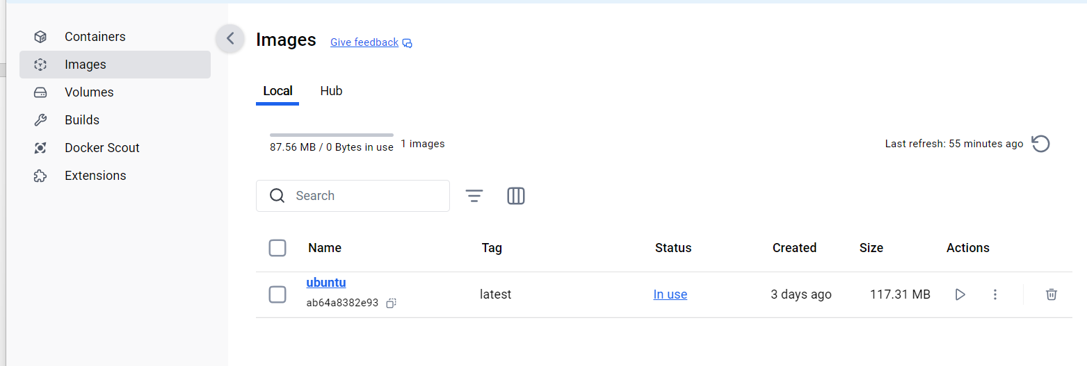

1. **Now spin up the container**

Using command docker run -it –name anisible_manged_node –hostname managed-node -p 2222:22 ubuntu bash

1. **You should be able to see the container running in Docker Desktop**

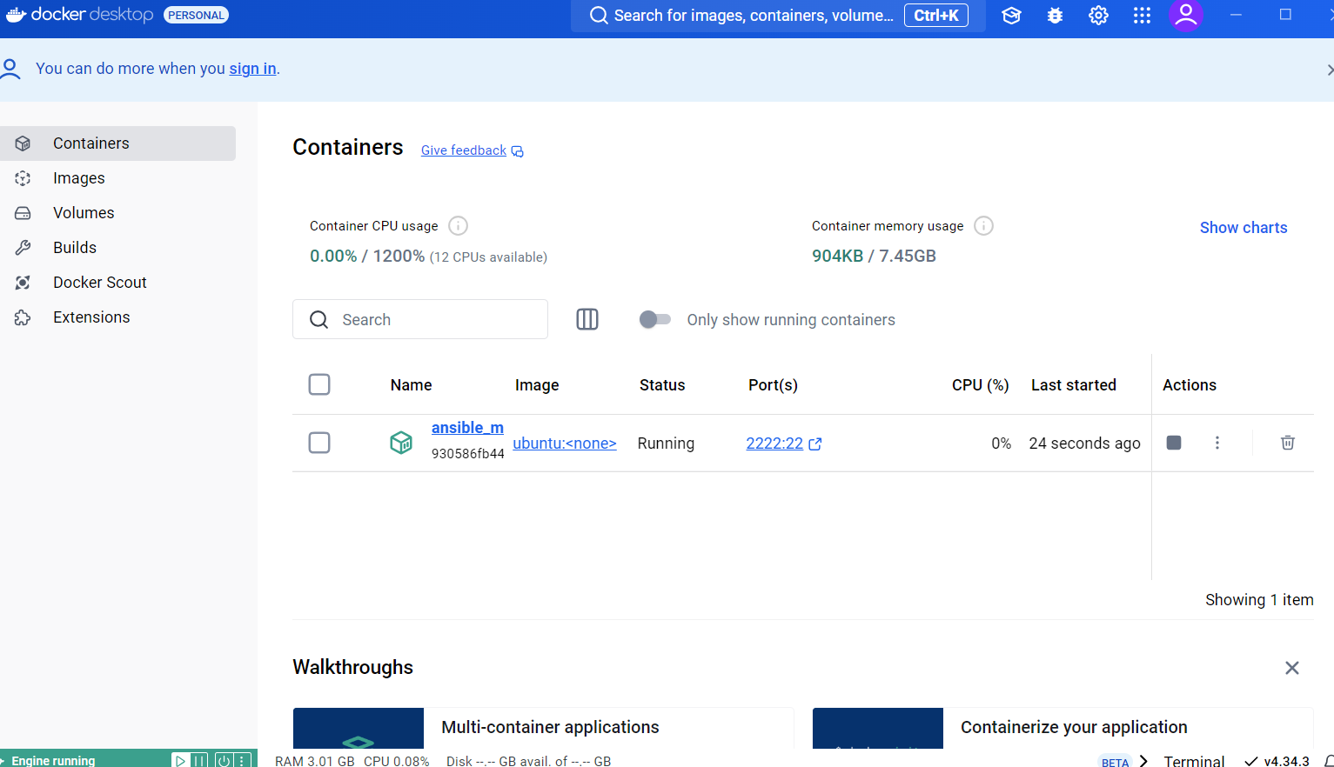

1. **Now we’ve entered the bash (CMD) of the container. Now install SSH and Python3 on the container using this bash:**

**apt install -y openssh-server python3**

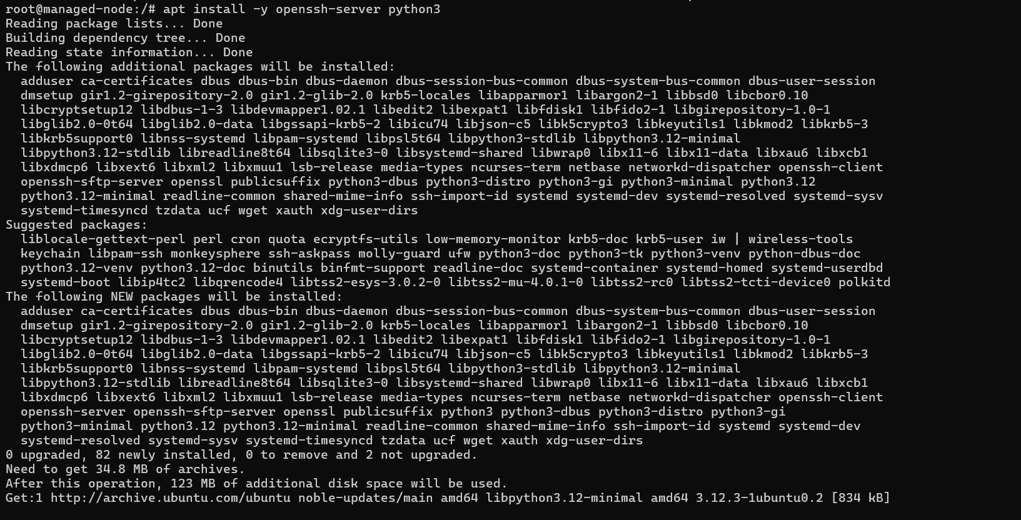

1. **Now start SSH on the container**

**Using** service ssh start **command**

1. **Now setup password for SSH on the container**

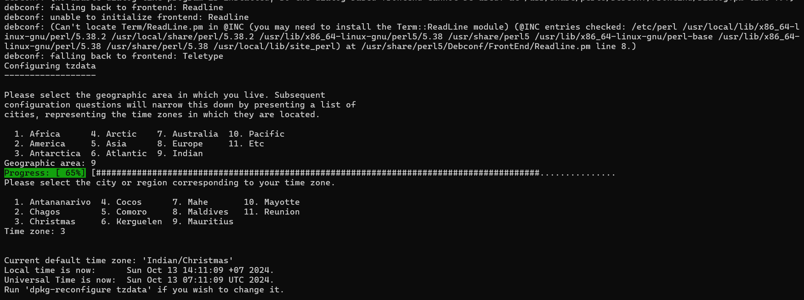

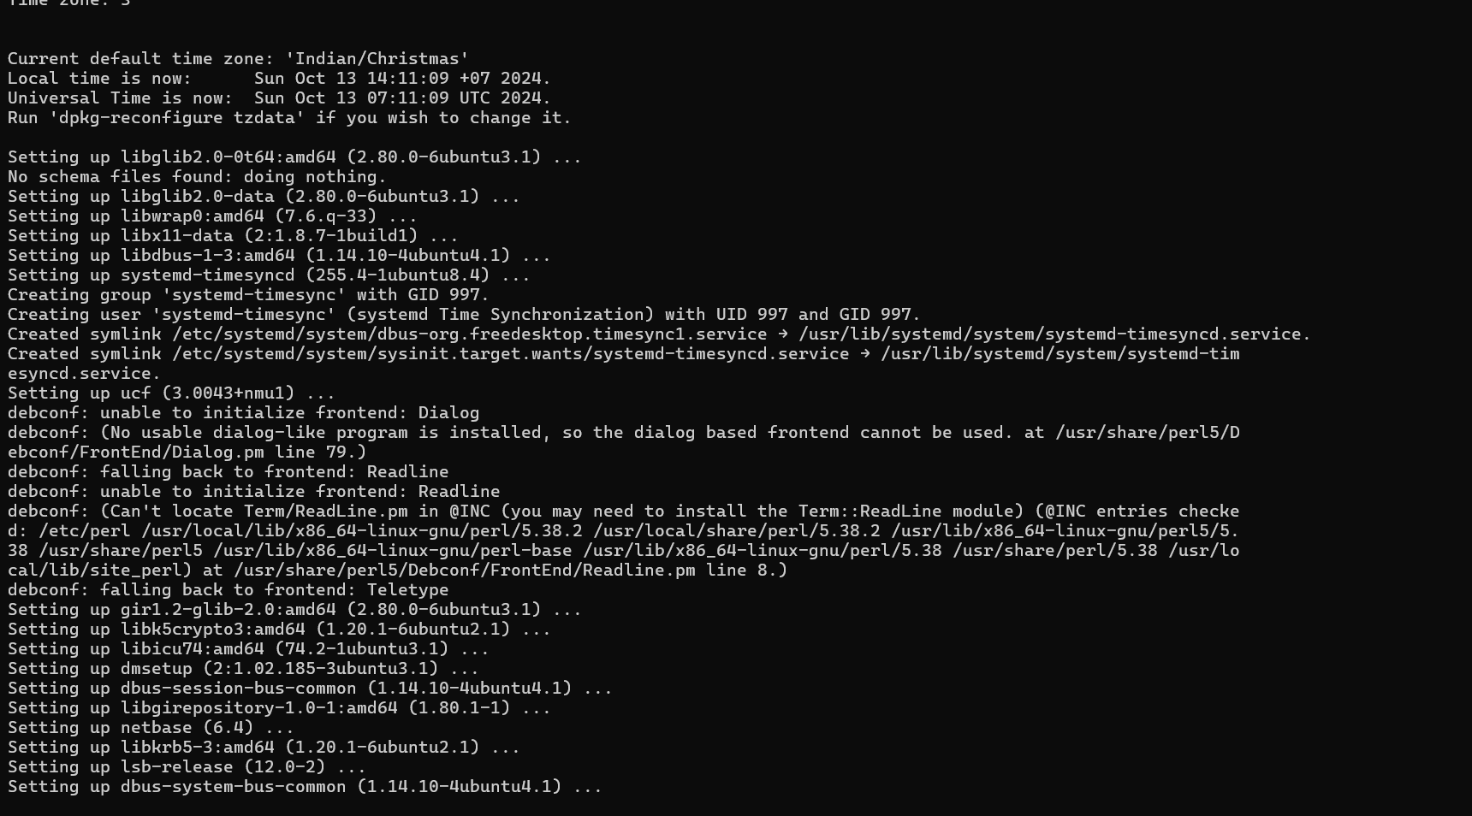

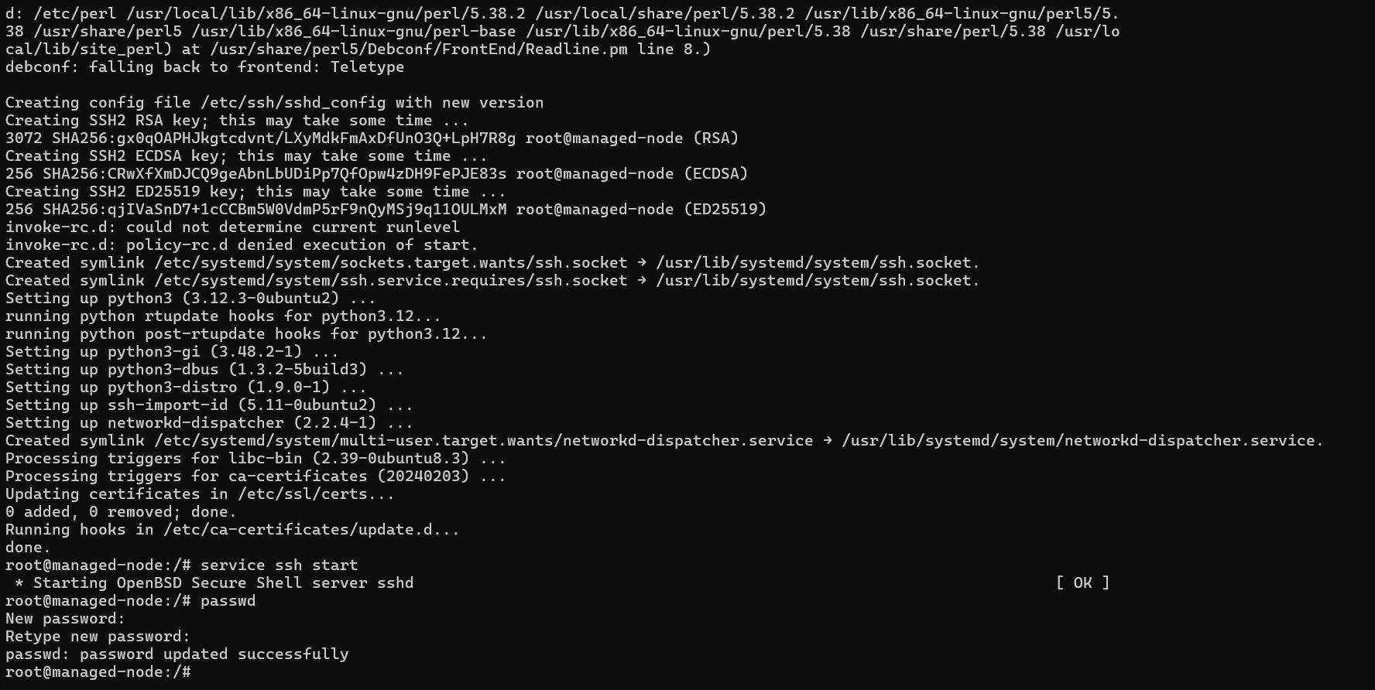

1. **Now we install vim on the container’s bash**

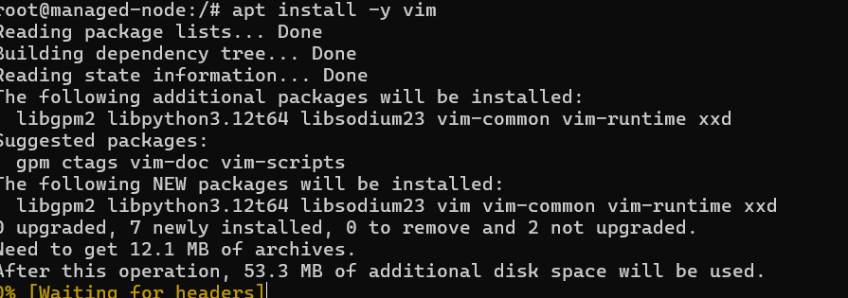

1. **Edit this file using “I” to insert and then press esc key and save using :wq**

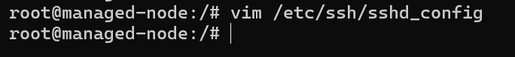

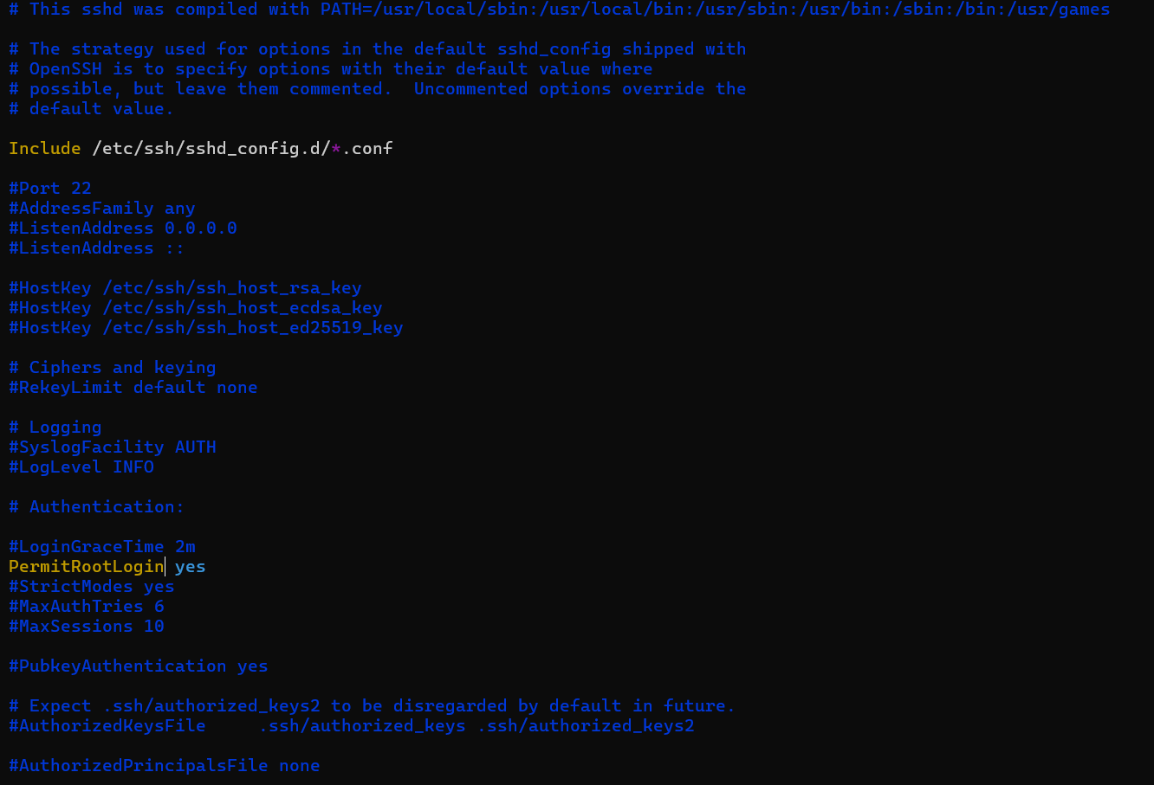

1. **Restart SSH on the container**



1. **On create SSH public key on WSL Ubuntu machine**

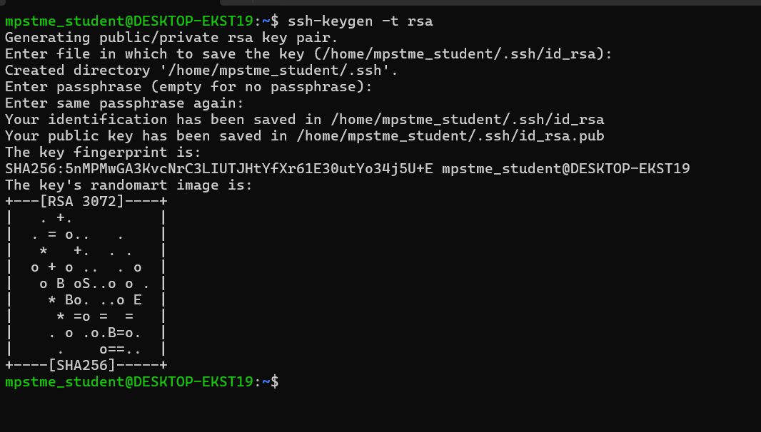

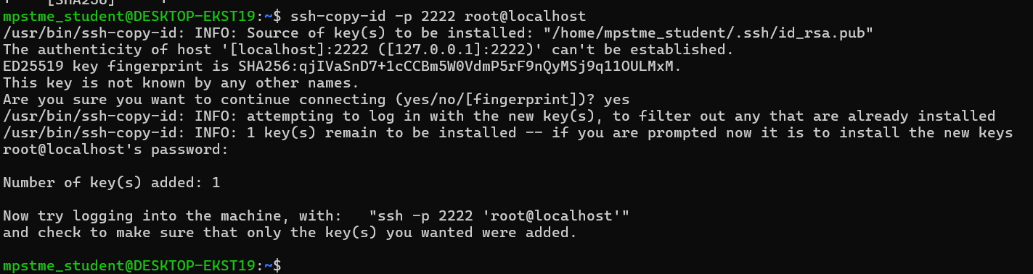

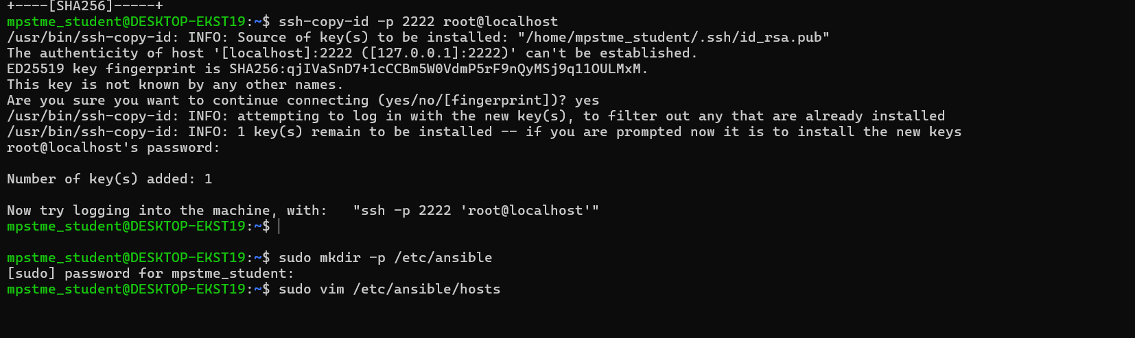

1. **Now add the manage nodes(docker codes) to the container**

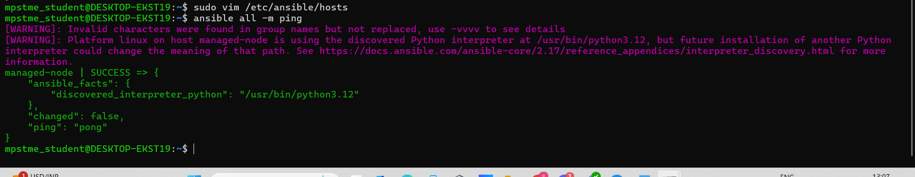

1. **Test your connections**

**Command: ansible all -m ping**

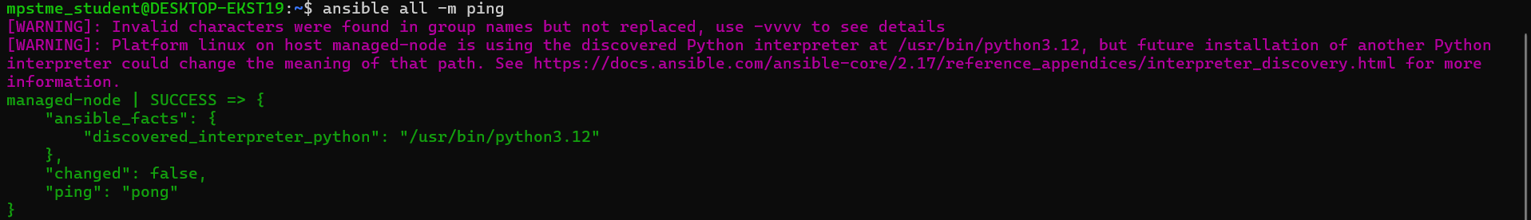

**Creating playbook steps:**

1. Created the playbook

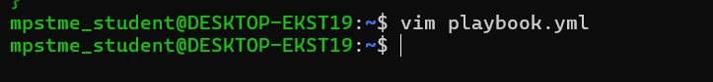

1. Opens an editor write your content there :

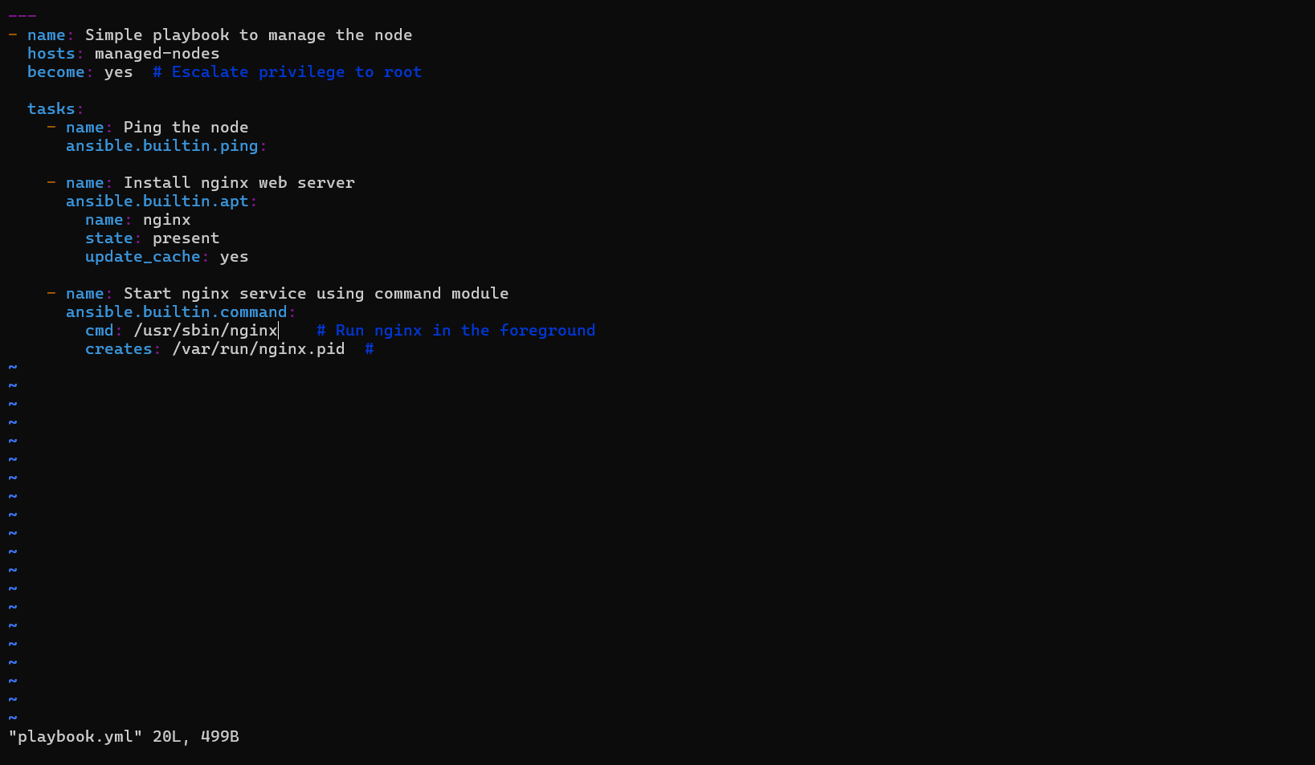

Then press esc key and then :wq to exit the editor

1. **To run your playbook, run command ansible-playbook playbook.yml**

**Error:**

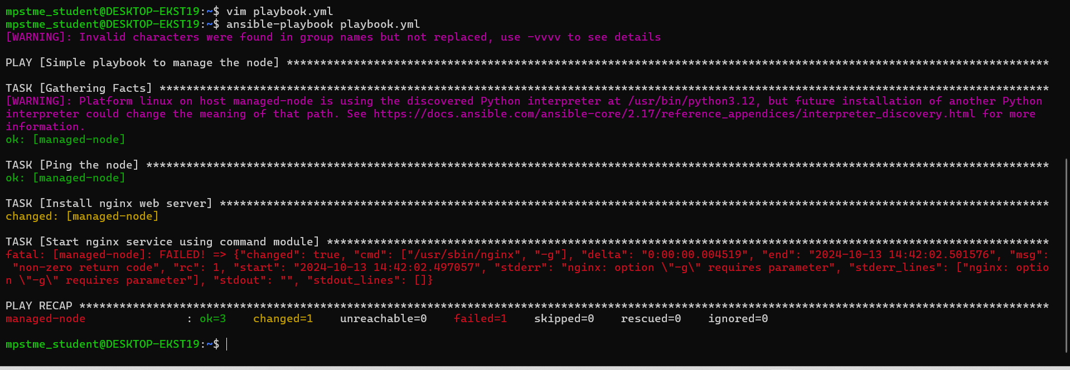

Success:

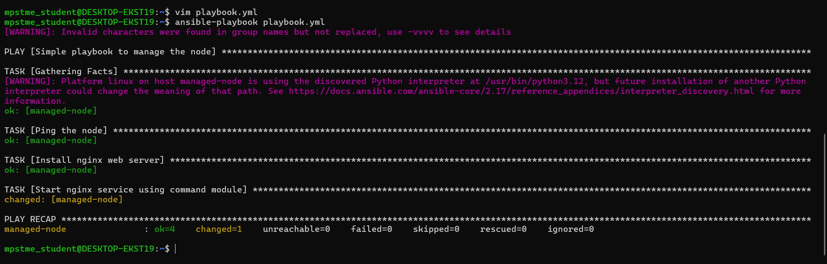

Practice task

**Task 1: Test Connectivity with localhost and printing a Hello world**

**Vim yml file:**

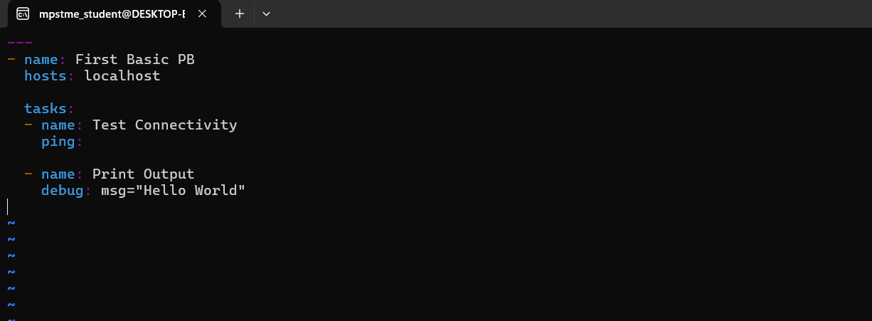

**Running the task:**

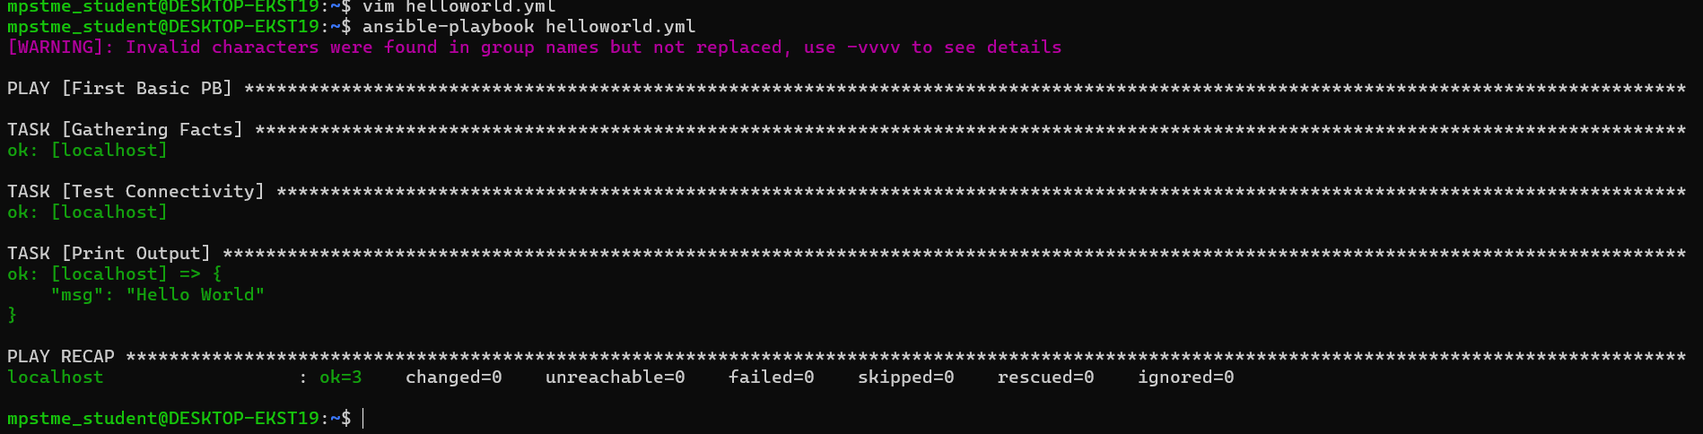

**Task 2: Installing a package on localhost**

Create a new playbook



Check if nginx is installed successfully:

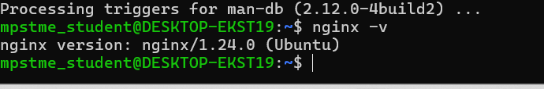

**TASK 2: If nginx service is running successfully:**

**systemctl status nginx.service**

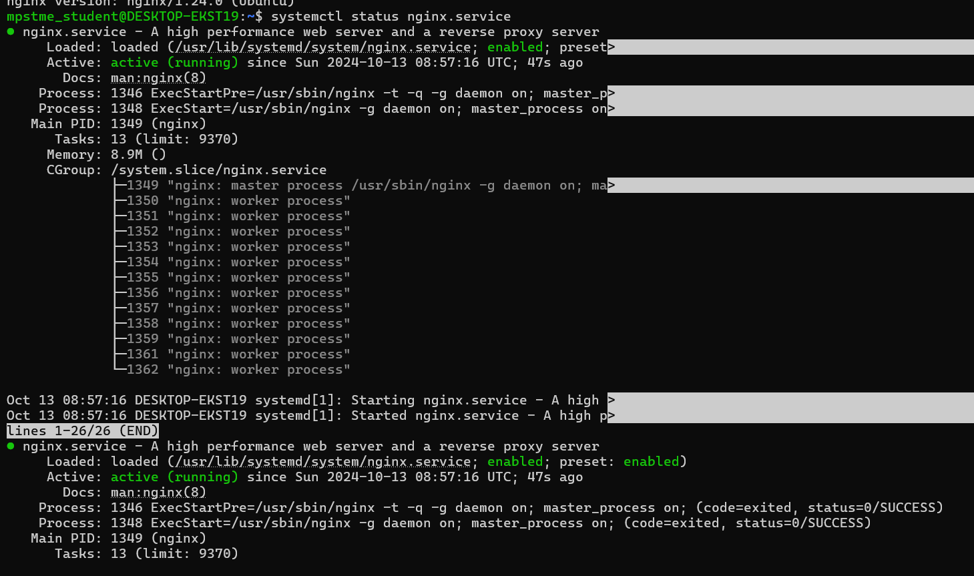

Creating a Playbook to run tasks on remote server:

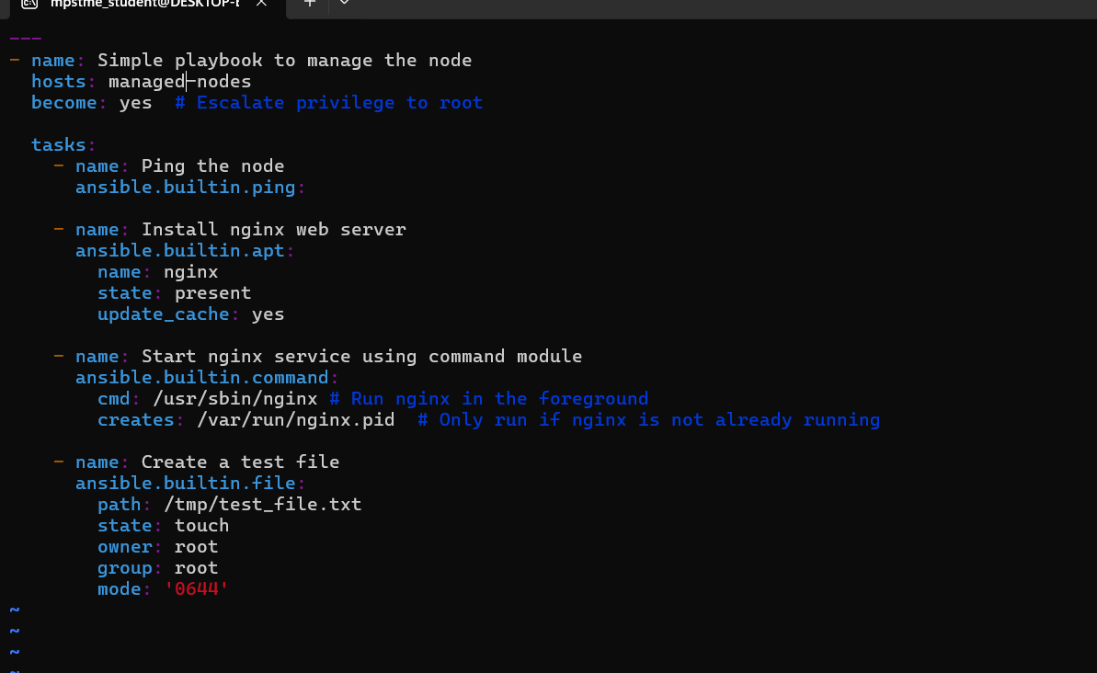

Run it :

